A Taste of Healthy

By The Travis Association for the Blind Wellness Committee

Introduction:

Hello and welcome to the Taste of Healthy Cookbook! Within these pages you will find a number of recipes for simple, healthy meals submitted by fellow members of our TAB workforce which foster and support goals of health and longevity. These recipes were compiled from books, online, and from the experience and culinary know-how of our employees, and showcase a variety of meals, ranging from entrees, sides, and desserts, proving the point that healthy and tasty can and do coexist quite well.

Don’t just take our word for it, however. Examples of many of these meals were dished out at our Taste of Healthy Potluck on August 25th, 2023, and to say that they were a hit is a vast understatement. They were a hammer blow to the notion that food that is good for you tastes bad. Heck, we even had brussels sprouts that tasted so good we ran out of them, surprising to those of us who have traumatic memories of those “devil vegetables” from childhood. The potluck was a resounding success, and we on the Wellness Committee plan to make it a yearly event.

Nutrition is too important to be made unpleasant. Macronutrients — proteins, carbohydrates, healthy fats, and micronutrients — vitamins, minerals, and electrolytes, are literally what keep us alive. They help us manage blood sugar, lose unhealthy mass or gain healthy mass, positively influence our mental landscape, live longer, and other benefits too numerous to list here. With all this in mind, we hope you enjoy cooking, eating, and sharing these recipes. Dig in.

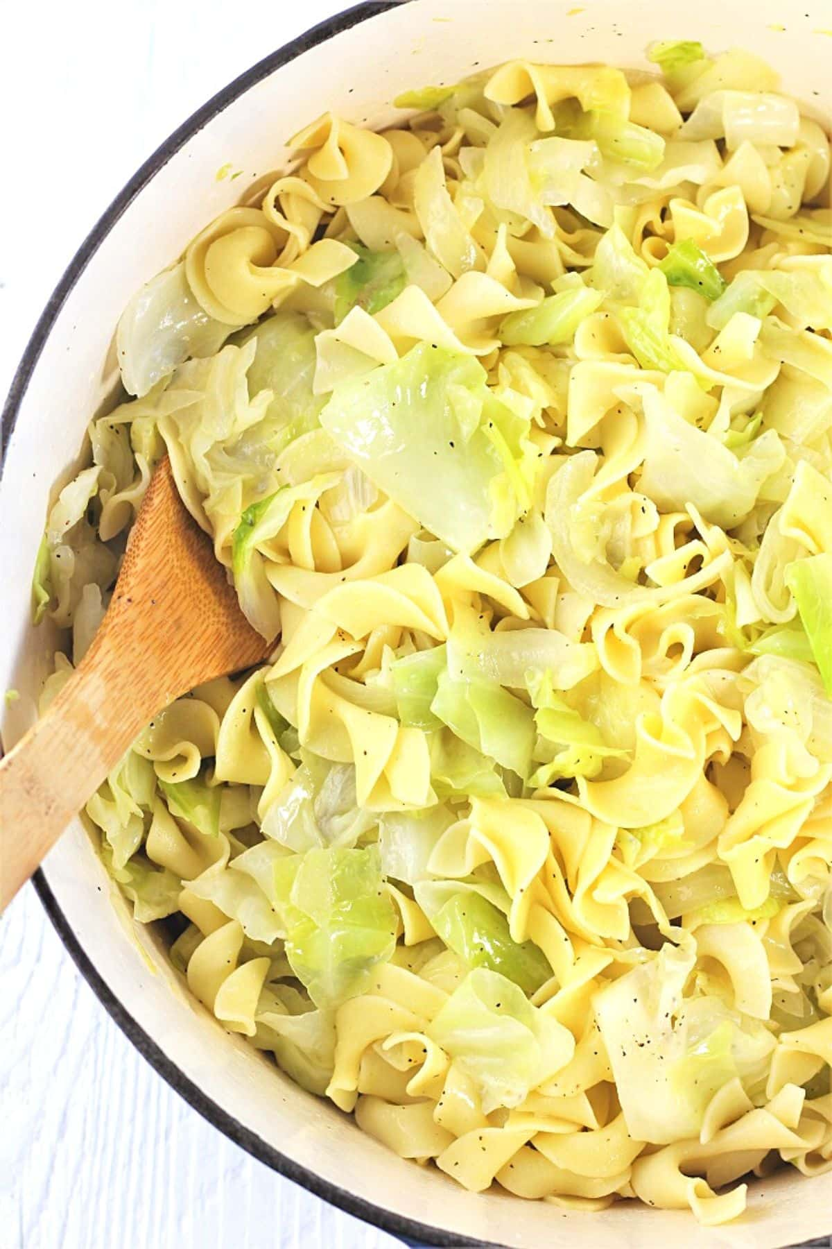
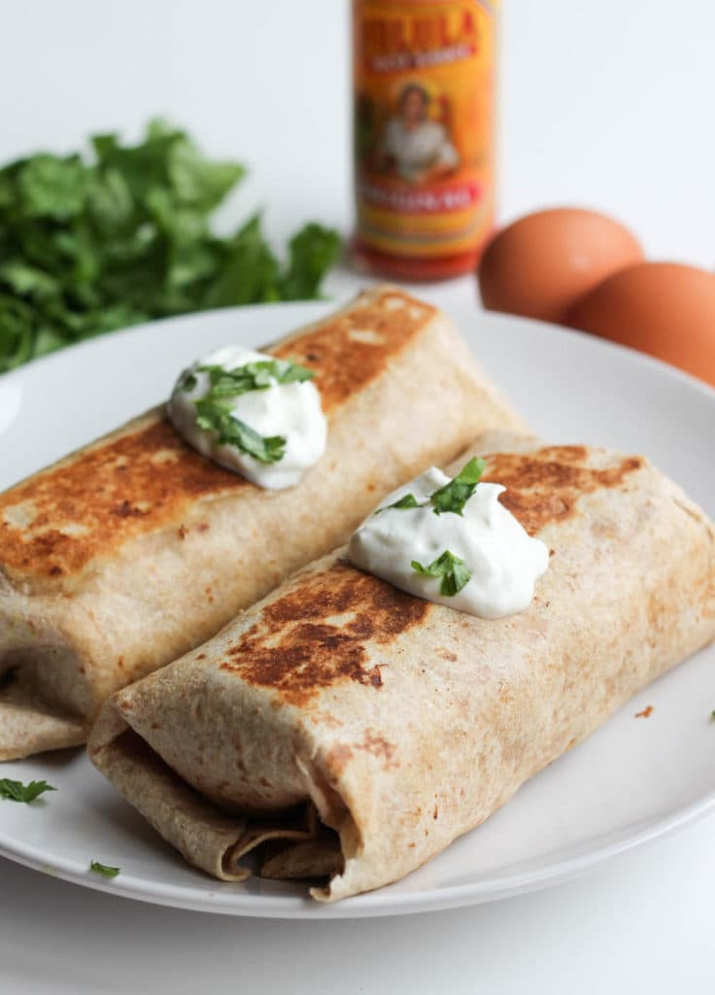
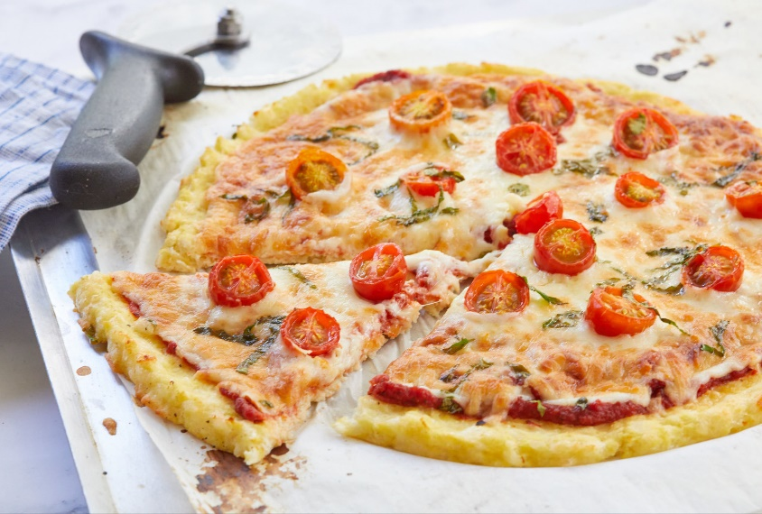
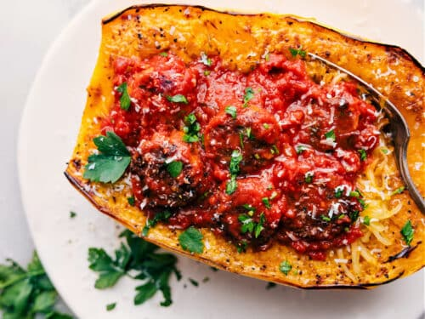
Entrées

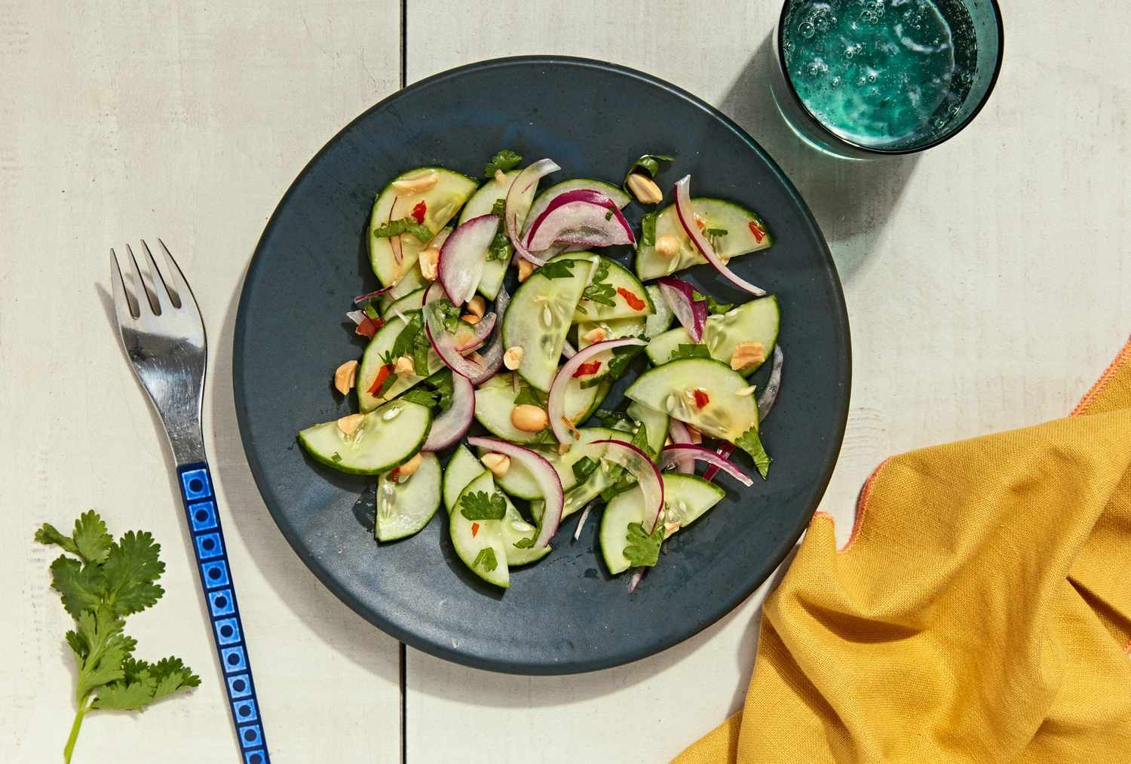

Cucumber Salad with Peanuts & Sweet Chili Sauce
By Flora Cruz

Time: 10 Minutes
Serves: 4

Ingredients:

- 1 large English cucumber (about 1 pound)
- ¼ medium red onion, very thinly sliced (about 1/2 cup)
- ¼ cup roughly chopped fresh cilantro
- 3 tablespoons roasted peanuts, roughly chopped or crushed
- ¼ cup distilled white vinegar or rice vinegar
- 1 tablespoon Thai sweet chili sauce
- ½ teaspoon salt

Directions:

- Cut cucumber in half lengthwise, then thinly slice crosswise into half-moons.
- Place the cucumber slices in a large bowl with onion, cilantro and peanuts.
- Stir vinegar, sweet chili sauce and salt In a small bowl until the salt is dissolved. Drizzle over the cucumber salad and toss to combine. Serve immediately.

Haluski - Cabbage and Noodles
By Heather Stivers

Time: between 45 and 68 minutes
Serves: 12

Ingredients:

- 1 (16 ounce) package medium-wide egg noodles
- 1 cup butter, divided
- 2 large onions, chopped
- 2 small heads cabbage, cored and cut into 1-inch pieces
- salt & ground black pepper and seasonings to taste

Directions:

- Preheat the oven to 300 degrees F (150 degrees C).
- Fill a large pot with lightly salted water and bring to a rolling boil. Stir in egg noodles and return to a boil. Cook noodles uncovered, stirring occasionally, until tender but slightly firm, about 5 minutes. Drain well and set aside.
- Melt 1/2 cup butter in a large skillet over medium-low heat. Add onions; cook and stir until translucent, 5 to 10 minutes.
- Add cabbage and remaining 1/2 cup butter to onions; cook and stir until cabbage is softened but not browned, 5 to 8 minutes. Season with salt & black pepper and seasonings.
- Place cooked noodles and cabbage mixture in a large roasting pan; stir gently to combine. Sprinkle with more salt & black pepper and seasonings, if desired.
- Bake in the preheated oven until golden brown on top, 30 to 40 minutes

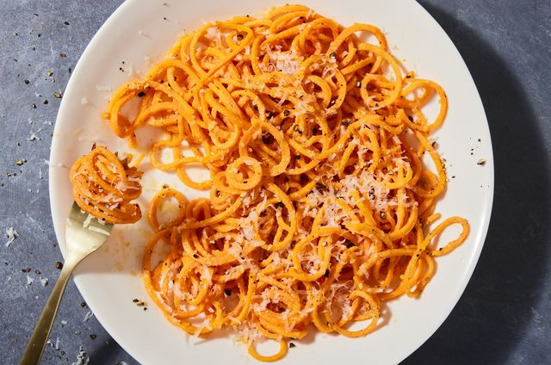

Cacio E Pepe Sweet Potato Noodles
By Kimberly Blas

Prep time: 25 minutes
Total time: 30 minutes
Serves: 2
Calories per serving: 430

Ingredients:

- 2 tbsp. extra-virgin olive oil, divided
- 12 oz. spiralized sweet potatoes (sweet potato noodles), cut about 12" long
- 1 1/2 tsp. (or more) kosher salt
- 1 tbsp. unsalted butter
- 1 tsp. freshly ground black pepper, plus more
- 1/2 c. finely shredded Parmesan (about 1 oz.), plus more for serving

Directions:
- Arrange all prepped and measured ingredients within easy reach of the stove. (The cooking in this recipe goes quickly, so it’s essential to have everything ready before beginning.)
- In a medium nonstick skillet over medium-high heat, heat 1 tablespoon oil. Add potato noodles and salt and cook, tossing occasionally, until slightly softened but still a bit crunchy, 2 to 3 minutes.
- Meanwhile, in a large skillet over medium-low heat, melt butter with remaining 1 tablespoon oil. Add pepper and cook, swirling pan, until fragrant, 30 seconds to 1 minute. Add noodles, Parmesan, and Pecorino and toss just until combined; season with salt, if needed.
- Divide noodle mixture among bowls. Top with more Parmesan and pepper.

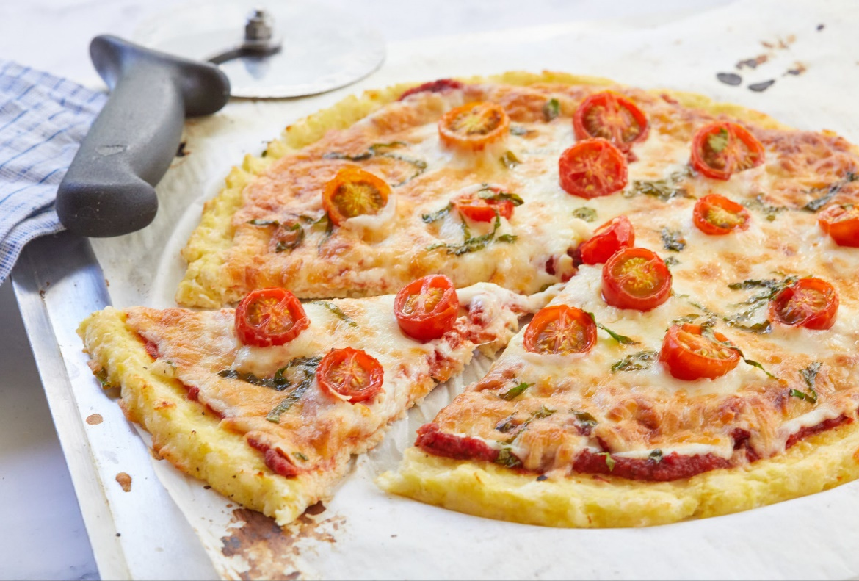

Cauliflower Pizza Crust
By Kimberly Blas

Prep Time: 15 minutes
Total Time: 45 minutes
Yields: 2

Ingredients:

- 1 large head cauliflower, roughly chopped
- 1 large egg
- 2 c. shredded mozzarella, divided
- 1/2 c. freshly grated Parmesan, divided
- kosher salt
- 1/4 c. marinara or pizza sauce
- 2 cloves garlic, minced
- 1 c. grape or cherry tomatoes, halved
- Torn fresh basil, for serving
- Balsamic glaze, for drizzling

Directions:

- Preheat oven to 425°. In a large skillet, bring about 1/4" water to a boil. Season with salt. Add cauliflower in one even layer and cook until crisp-tender, 3 to 4 minutes. Transfer to a clean dish towel (or paper towels) and squeeze to drain water.
- Add drained cauliflower to food processor and pulse until grated. Drain excess water in paper towels.
- Transfer drained cauliflower to a large bowl and add egg, 1 cup mozzarella and 1/4 cup Parmesan, then season with salt.
- Transfer dough to a baking sheet lined with cooking spray and pat into a crust. Bake until golden and dried out, 20 minutes.
- Top crust with marinara, remaining mozzarella and Parm, garlic and tomatoes and bake until cheese is melted and crust is crisp, 10 minutes more.
- Garnish with basil and drizzle with balsamic glaze.

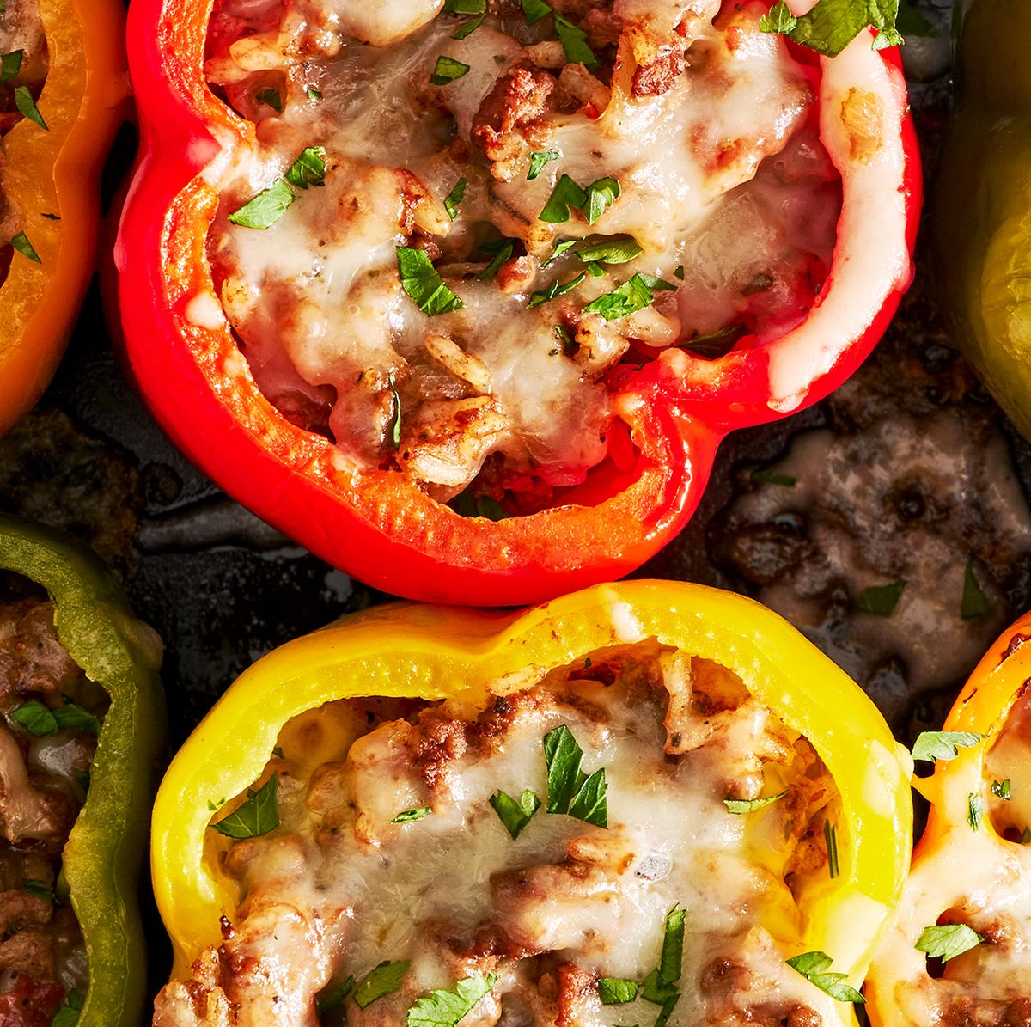

Stuffed Peppers
By Kimberly Blas

Prep Time: 20 minutes
Total time: 1 hour and 30 minutes
Servings: 6
Calories per serving: 419

Ingredients:

- 1/2 c. uncooked white or brown rice
- 2 tbsp. extra-virgin olive oil, plus more for drizzling
- 1 medium yellow onion, chopped
- 3 cloves garlic, finely chopped
- 2 tbsp. tomato paste
- 1 lb. ground beef
- 1 (14.5-oz.) can diced tomatoes
- 1 1/2 tsp. dried oregano
- Kosher salt
- Freshly ground black pepper
- 6 bell peppers, tops and cores removed
- 1 c. shredded Monterey jack
- Chopped fresh parsley, for serving

Directions:

- Preheat oven to 400°. In a small saucepan, prepare rice according to package instructions.
- Meanwhile, in a large skillet over medium heat, heat oil. Cook onion, stirring occasionally, until softened, about 7 minutes. Stir in garlic and tomato paste and cook, stirring, until fragrant, about 1 minute more. Add ground beef and cook, breaking up meat with a wooden spoon, until no longer pink, about 6 minutes. Drain excess fat.
- Stir in rice and diced tomatoes; season with oregano, salt, and pepper. Let simmer, stirring occasionally, until liquid has reduced slightly, about 5 minutes.
- Arrange peppers cut side up in a 13"x9" baking dish and drizzle with oil. Spoon beef mixture into each pepper. Top with cheese, then cover baking dish with foil.
- Bake peppers until tender, about 35 minutes. Uncover and continue to bake until cheese is bubbly, about 10 minutes more.
- Top with parsley before serving.

Baked Egg Cups
By Randall Babbitt
Prep time: 10 minutes
Total time: 30 minutes
Servings: 12

Ingredients:

- 6 large eggs
- 1 cup chopped spinach
- 1/2 cup diced tomatoes
- 1/2 cup diced bell peppers
- 1/2 cup grated cheese (cheddar, mozzarella, or your favorite)
- Salt and pepper to taste
- 2 tablespoons chopped fresh chives or green onions (for garnish)

Directions:

- Preheat the oven to 375°F (190°C). Grease a muffin tin with cooking spray or olive oil
- In each muffin cup, evenly distribute the chopped spinach, diced tomatoes, and diced bell peppers.
- Crack one egg into each muffin cup over the vegetables.
- Sprinkle the grated cheese on top of each egg, and season with salt and pepper.
- Bake in the preheated oven for about 12-15 minutes, or until the egg whites are set.
- Remove the egg cups from the muffin tin and let them cool slightly.
- Garnish with chopped fresh chives or green onions before serving.

Spaghetti Squash with Marinara Sauce and Turkey Meatballs
By Randall Babbitt

Prep time: 20 minutes
Total time:1 hour
Servings: 4

Ingredients:

- 1 medium-sized spaghetti squash
- 1 lb (450g) ground turkey (or ground chicken)
- 1/2 cup whole wheat bread crumbs
- 1 large egg
- 1 teaspoon dried oregano
- 1 teaspoon garlic powder
- 1 teaspoon dried basil
- Salt and pepper to taste
- Italian seasoning to taste
- 2 tablespoons olive oil
- 2 cups marinara sauce (store-bought or homemade)
- Fresh basil leaves for garnish

Directions:

- Preheat the oven to 400°F (200°C).
- Cut the spaghetti squash in half lengthwise and scoop out the seeds.
- Drizzle 1 tablespoon of olive oil over the cut sides of the squash, sprinkle with salt and pepper and Italian seasoning, and place them cut-side down on a baking sheet.
- Roast the squash in the preheated oven for about 30-40 minutes or until the flesh is tender and easily shreds into "spaghetti" strands with a fork.
- While the squash is roasting, prepare the turkey meatballs. In a bowl, mix the ground turkey, whole wheat bread crumbs, egg, garlic powder, dried oregano, dried basil, salt, and pepper
- Form the mixture into meatballs, about 1 to 1.5 inches in diameter.
- Heat a tablespoon of Olive oil in a large Skillet over medium heat (5 to 7 minutes)
- Once the oil is heated, cook until they are fully cooked and browned on all sides. This should take about 8 to 10 minutes.
- Heat the marinara sauce in a separate saucepan.
- Once the spaghetti squash is done, use a fork to shred the flesh into "spaghetti" strands (rake fork from the outside skin to the center)
- Serve the spaghetti squash with the marinara sauce and turkey meatballs. Garnish with fresh basil leaves.

Suppertime Egg Burritos
By Susie Ingram

Servings: 6
Calories per serving: 296
Fat per serving: 11
cholesterol per serving: 112 mg
carbohydrates per serving: 31 G
Fiber per servings: 1 G
Protein per serving: 19 grams

Ingredients:

- 1 cup sliced fresh mushroom
- 1 medium chopped onion
- ½ cup chopped green peppers
- 2 teaspoons canola oil
- 3 eggs
- 1 and ¼ cups egg substitute
- 3 tablespoons reduced fat cream cheese, cubed
- ¼ teaspoon salt
- 1/8 teaspoon pepper
- 6 flour tortillas (8 inches) warmed
- ¾ cup shredded reduced fat cheddar cheese
- ½ cup salsa

Directions:

- In a non-stick skillet, sauté mushrooms, onion, and green pepper in oil until tender.
- Remove and keep warm.
- Cook and stir over medium heat until eggs are completely set.
- Stir in sautéed vegetables. Spoon about a half cup down the center of the tortilla; top with cheddar cheese and salsa.
- Fold ends and sides over filling. Serve immediately.

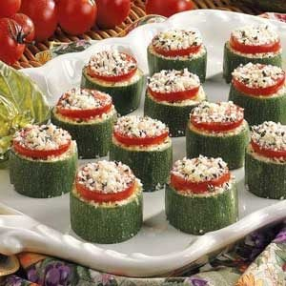
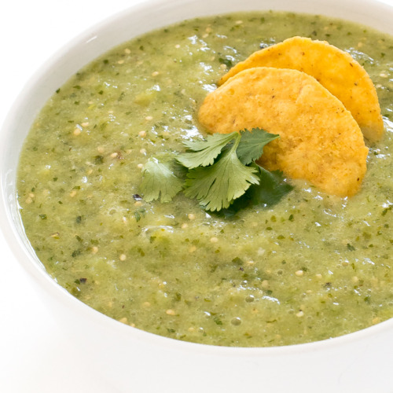
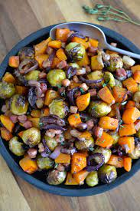
Sides
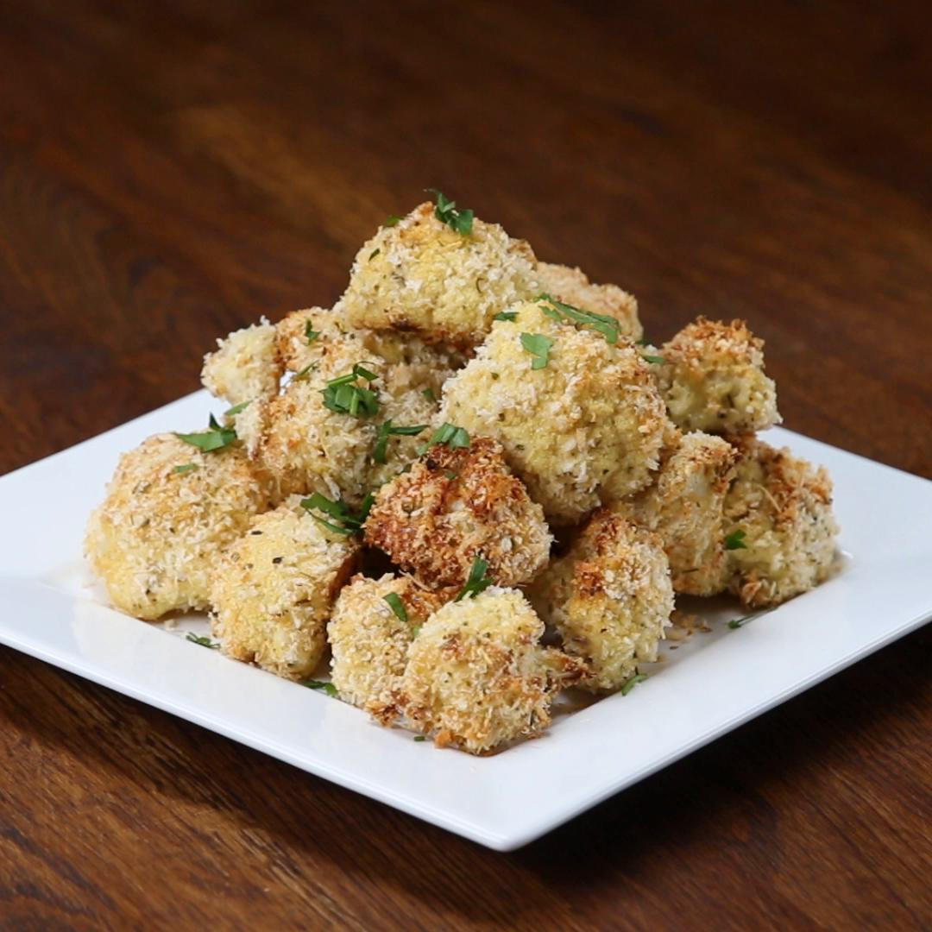

Sheet Pan Roasted Brussel Sprouts, Butternut Squash, & Red Onion

By Heather Stivers

Serves: 6

Ingredients:

- 2 cups cubed butternut squash (approximately 1 inch cubes)
- 2 cups small Brussel sprouts
- 2 red onion thinly sliced
- 3 tbsp olive oil
- 1 tbsp balsamic vinegar
- 2 tsp Dijon mustard
- 1 tsp thyme
- 1/4 tsp salt
- 1/2 tsp pepper

Directions:

- Preheat the oven to 400 degrees.
- Wash and cut off any of the tough outer leaves of Brussel sprouts. Cut any of the larger brussel sprouts in half.
- Slice red onion.
- Place the cubed butternut squash, Brussel sprouts, and red onion on a large baking sheet.
- In a bowl whisk together the olive oil, balsamic, mustard, thyme, salt and pepper and then pour over the veggies on the baking sheet.
- Place everything in the oven and bake for 35 minutes tossing the veggies half way through baking to ensure they evenly cook.

Garlic Parmesan Cauliflower Bites

By Randall Babbitt

Serves:

Ingredients:

1 medium-sized head of cauliflower, cut into bite-sized florets
1/2 cup all-purpose flour (or almond flour for a gluten-free option)
1 teaspoon garlic powder
1/2 teaspoon paprika
1/2 teaspoon salt
1/4 teaspoon black pepper
2 large eggs, beaten
1 cup breadcrumbs (use whole wheat or panko breadcrumbs for a healthier option)
1/2 cup grated Parmesan cheese
2 tablespoons melted butter or olive oil
Fresh parsley, chopped (optional, for garnish)

Directions:

1. Preheat the oven to 425°F (220°C).
2. Line a baking sheet with parchment paper or lightly grease it with cooking spray.
3. In a large bowl, mix the flour, garlic powder, paprika, salt, and black pepper.
4. Dip each cauliflower floret into the beaten eggs, then coat it with the flour mixture, shaking off any excess
5. In another bowl, combine the breadcrumbs and grated Parmesan cheese.
6. Roll each flour-coated cauliflower floret in the breadcrumb mixture until evenly coated.
7. Place the coated cauliflower bites on the prepared baking sheet, leaving some space between each piece.
8. Drizzle the melted butter or olive oil over the cauliflower bites to help them brown and crisp up in the oven.
9. Bake in the preheated oven for about 20-25 minutes or until the cauliflower is tender and the coating is golden and crispy.
10.

Optionally, garnish with chopped fresh parsley before serving.

Cheesy Zucchini Bites:

By Susie Ingram

Yields: 35

Ingredients:

- 5 medium zucchinis (about 6 inches long)
- 4 ounces blue cheese crumples
- 3 tablespoons grated parmesan cheese
- 1 teaspoon dried basil
- 1/8th teaspoon pepper
- 1 pint cherry tomatoes thinly sliced.

Directions:

- Cut zucchini in ¾-in. slices. Using a melon baller or small spoon, scoop out the insides and discard, leaving the bottom intact.
- Place zucchini on an ungreased baking sheet; spoon ½ teaspoon crumpled blue cheese into each.
- Combine the parmesan cheese, basil and pepper, sprinkle half over the blue cheese.
- Top each with a tomato slice; sprinkle with remaining parmesan mixture.
- Bake at 400 degrees for 5 to 7 minutes or until cheese is melted.
- Serve warm.

My Spicy Green Sauce
By Taryn Schriewer

Ingredients:

- 1 large or 2 small tomatillos
- 5 or 6 jalapenos with tops removed (deseeding optional)
- ½ yellow onion
- 4 or 5 garlic cloves
- 4-6 ounces of water
- 2 Tbsp. avocado oil
- Salt to taste
- ½ Tsp. cumin (optional)

Directions:

- Move rack to center of oven and preheat to 400 F.
- In a baking dish large enough to accommodate all the vegies with some movement, add the avocado oil and rinsed vegies and roll them to cover them in the oil.
- Bake for 25 to 30 minutes or until garlic and onion are soft and peppers and tomatillos are wrinkled on the outside.
- Add the water, salt and cumin to a blender or food processor and dissolve the salt. (Water should be salty to taste for best results)
- Add the cooked vegies and the remaining liquid in the dish and blend until smooth.
Notes: This salsa is verry flexible and all measurements are approximate and should be used as a guide. Baking the vegies ensures that they are evenly roasted and frees up time for other tasks. This budget friendly salsa is good on most tacos or as a dip and can be manipulated until you get a flavor you like.
Enjoy!

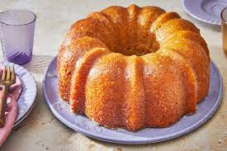
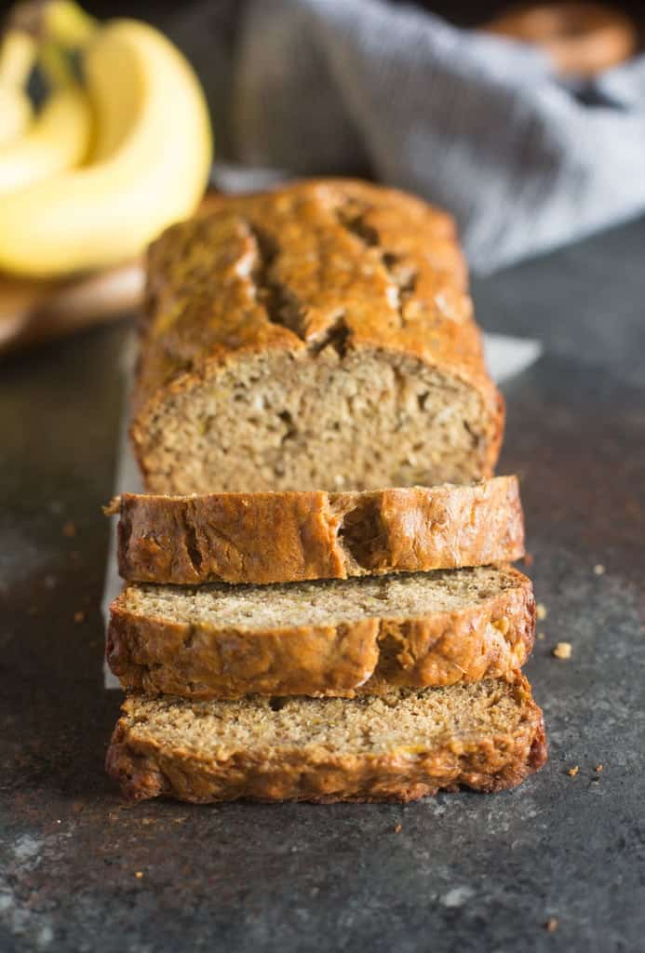
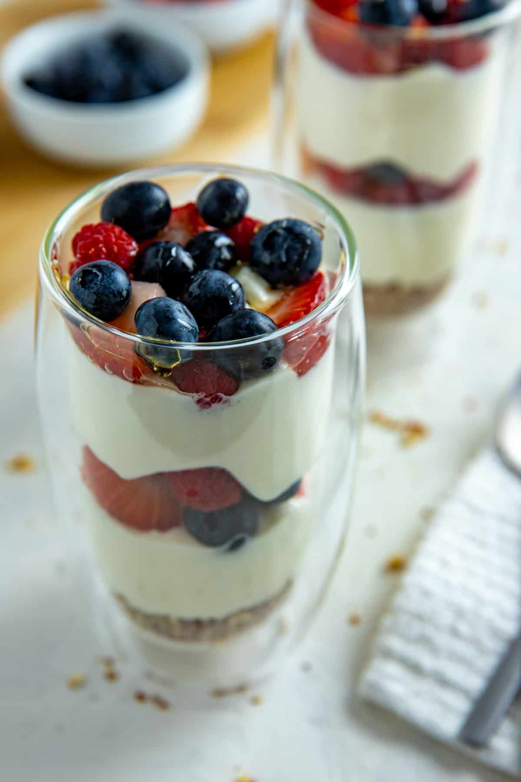
Desserts

Healthy Banana Bread
By Amanda Lizotte

Time: 50 Minutes

Ingredients:

- 2 cups Oat Flour (or white, spelt, 240g)
- 1 teaspoon Baking Soda
- ¾ teaspoon of Baking Powder
- ¾ teaspoon Salt
- Cinnamon (optional ½ tsp)
- Mini Chocolate Chips (optional ½ cup)
- 1 ½ cups Overripe Bananas (mashed)
- ½ cup Yogurt (suggest almond milk yogurt)
- ½ cup Pure Maple Syrup (honey or agave)
- 1 tablespoons Any Sweetener of choice or 1/16 tsp Uncut Stevia
- ½ cup Oil or Milk of choice
- 2 teaspoons Pure Vanilla extract

Directions:

- Preheat oven to 350 F.
- Grease a 9x5 loaf pan, or line with parchment paper.
- Combine dry ingredients in a bowl.
- In a separate bowl Whisk liquid ingredients together.
- Pour wet into dry ingredients, and stir to form a batter.
- Smooth into the prepared pan. If desired, press some chocolate chips into the top.
- Bake on the center rack 40 minutes, then do not open the oven door but turn off the heat and let sit in the closed oven 10 additional minutes. If your bread is still undercooked at this time, cover the top with foil. Turn the oven back on and continue baking, checking every 5 minutes, until a toothpick inserted into the center comes out clean. Let cool completely.
- Cover and refrigerate overnight. Taste and texture are much better the second day (and even better the third day as it gets sweeter). Leftovers can be sliced and frozen for up to a month.

This healthy banana bread recipe is so moist and sweet, everyone is always shocked to find out it’s actually good for you!

Low fat parfait

By Susie Ingram

Ingredients:

- 4, 8-ounce cups of nonfat Greek yogurt
- A variety of berries (blue berries, blackberries, strawberries)
- 4 tablespoons of coca (powder)
- 8 packets of Truvia sweetener
- 4 fresh, pitted cherries

Directions:

- Mix all of the yogurt together with 4 packets of Truvia. Mix well.
- Wash berries
- Mix 6 or 8 tablespoons of water with the coca powder and add the other 4 packets of truvia. Mix well.
- Scoop some of the yogurt into a dessert dish, add a variety of the berries, add more yogurt and then more berries.
- Finally, add the last of the yogurt.
- Drizzle the chocolate on top and add a cherry!
Enjoy

